Data Set: HEART DISEASE

Topic: Health Analysis and Impact of various Activities on Health

Link: [**https://drive.google.com/file/d/12qD-O5Gw0rs7ghu6jQHv7s5BX2FLdq-p/view**](https://drive.google.com/file/d/12qD-O5Gw0rs7ghu6jQHv7s5BX2FLdq-p/view)

**Dataset Attributes:**

HeartDisease object

BMI float64

Smoking object

AlcoholDrinking object

Stroke object

PhysicalHealth int64

MentalHealth int64

DiffWalking object

Sex object

AgeCategory object

Race object

Diabetic object

PhysicalActivity object

GenHealth object

SleepTime int64

Asthma object

KidneyDisease object

SkinCancer object

WORKSHEETS

1. **SLEEP TIME ANALYSIS:**

People of age group 60-74 have the most sleep time.

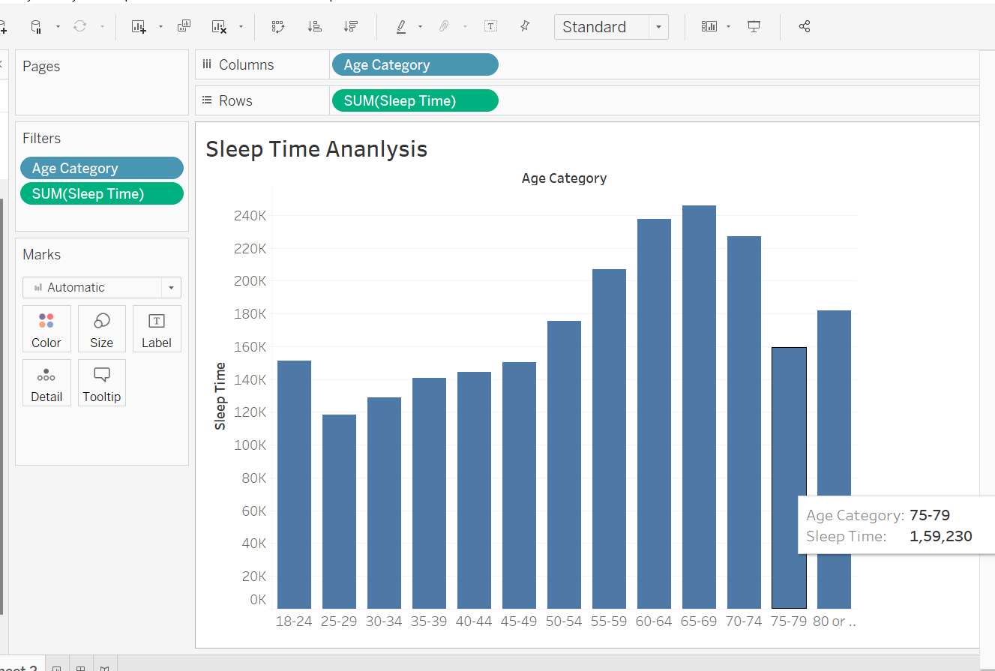

1. HEART DISEASES:

Mostly heart disease is observed in the age group of people in 50-75.

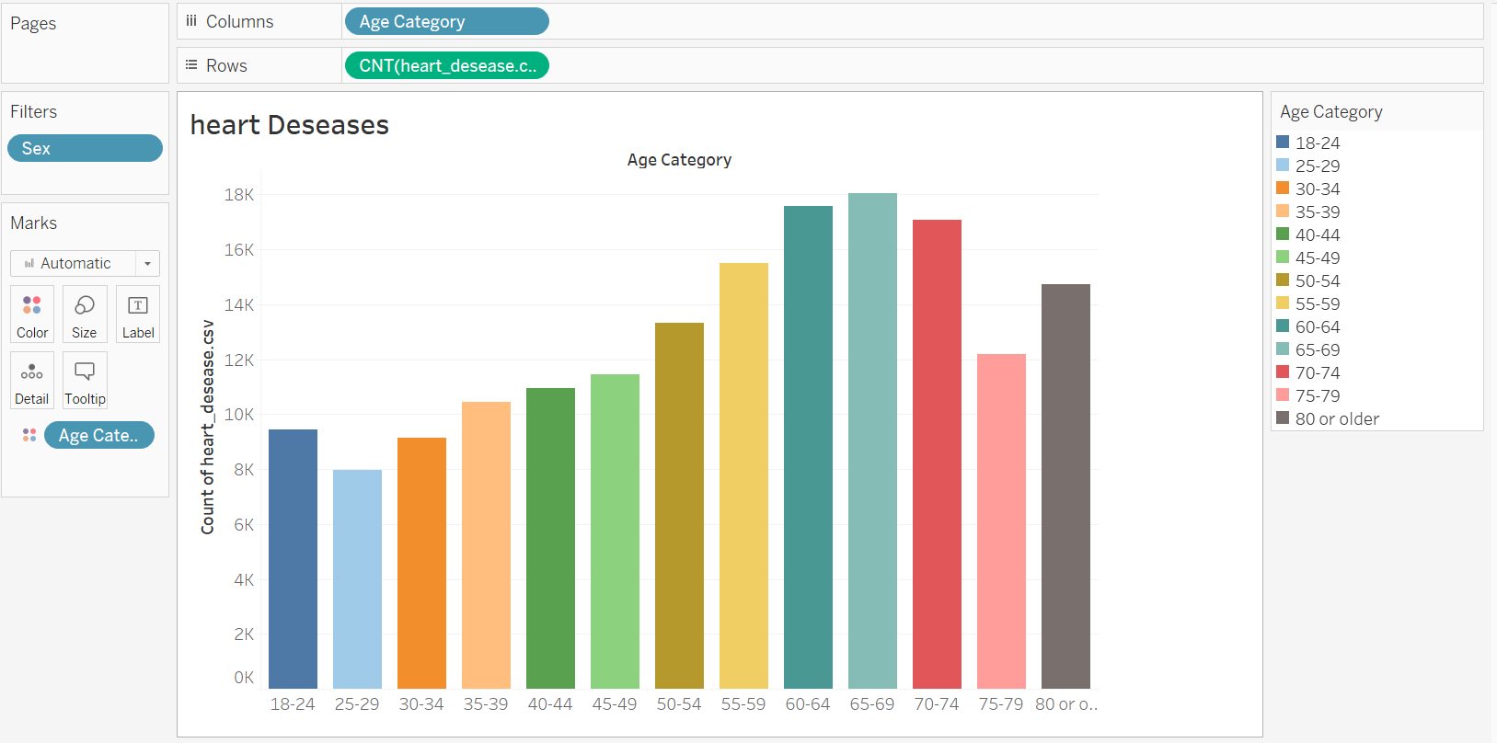

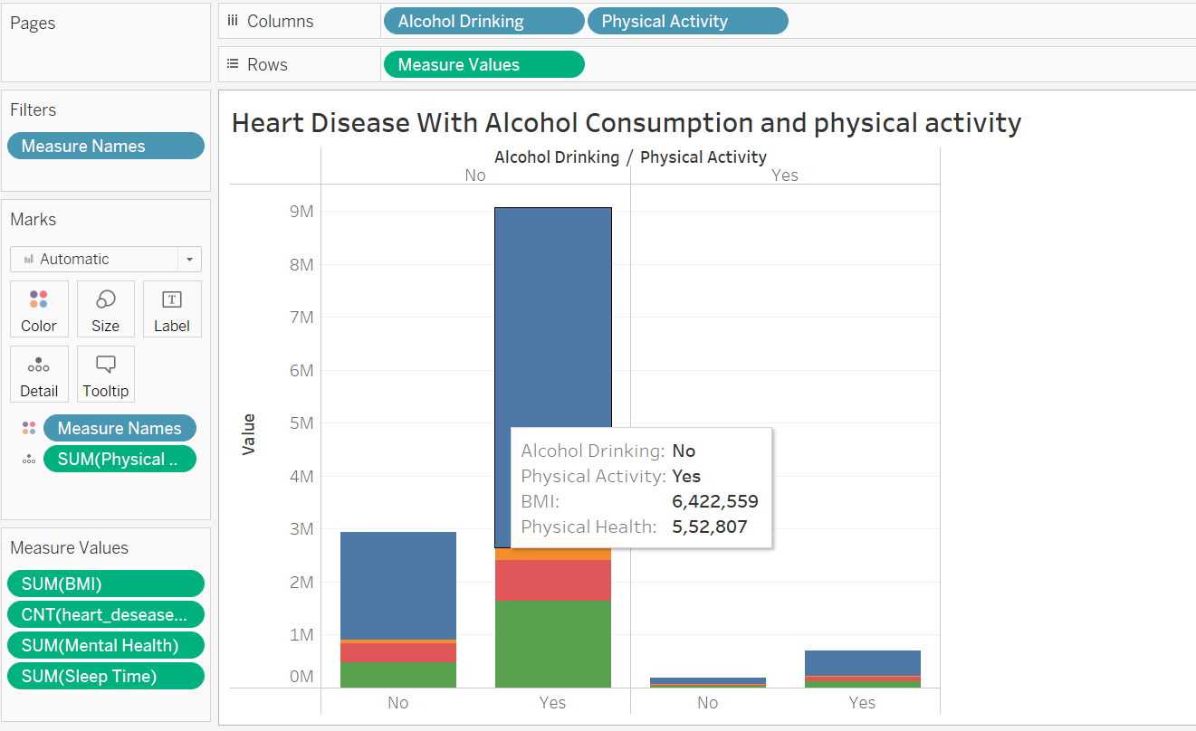

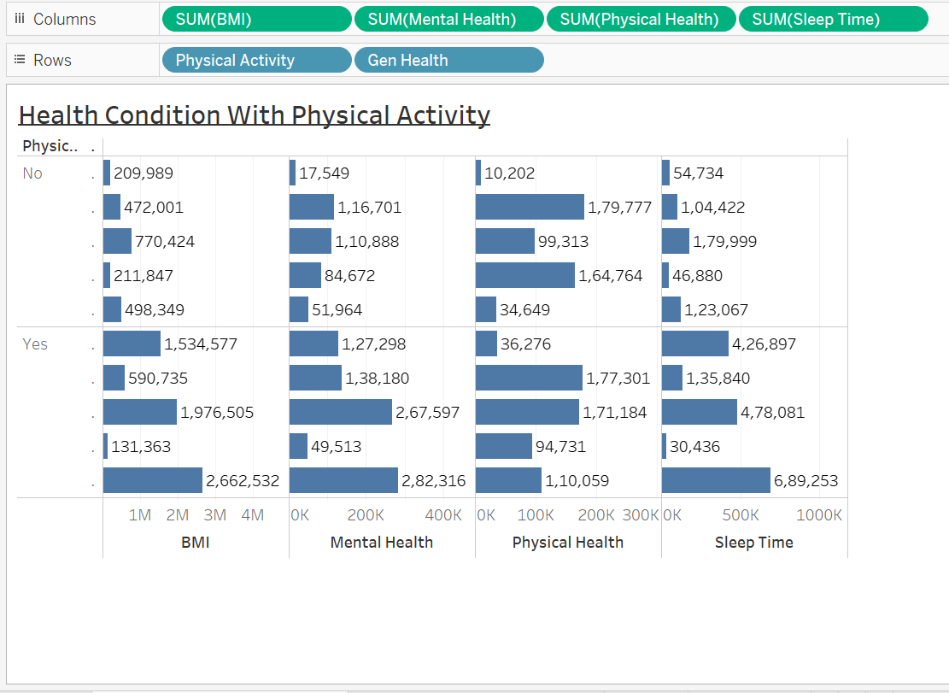

DASHBOARD

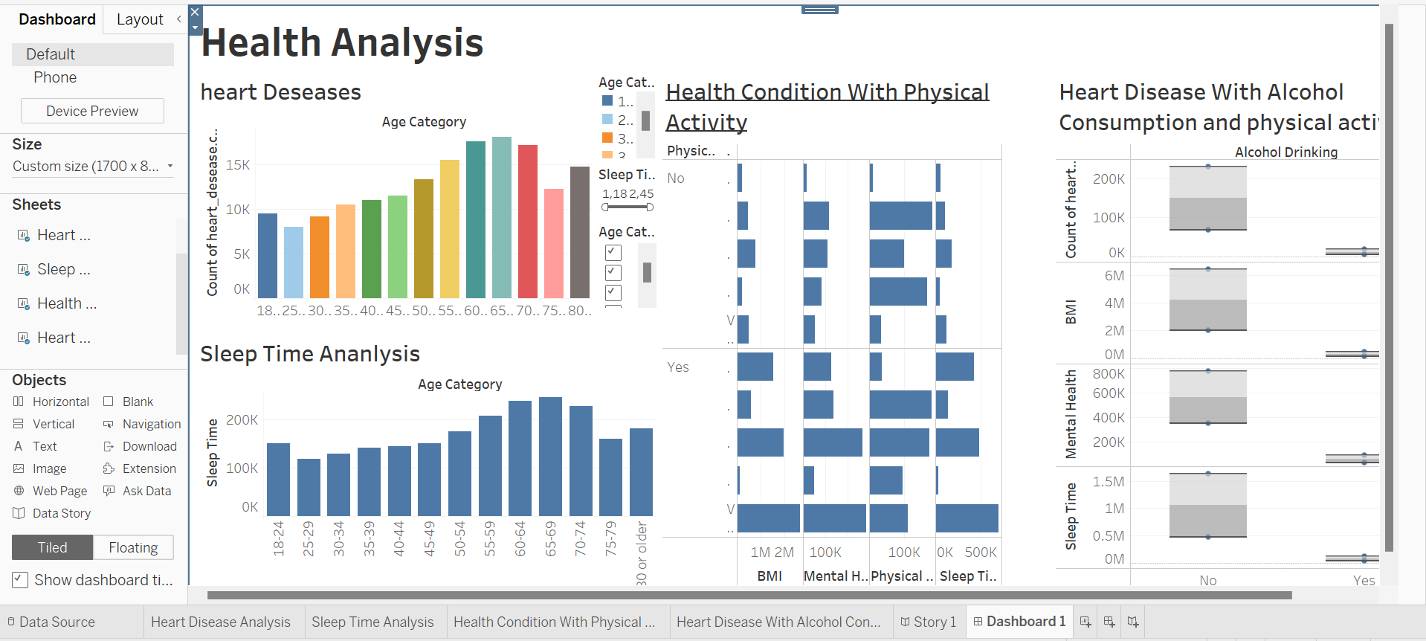

STORY

1. 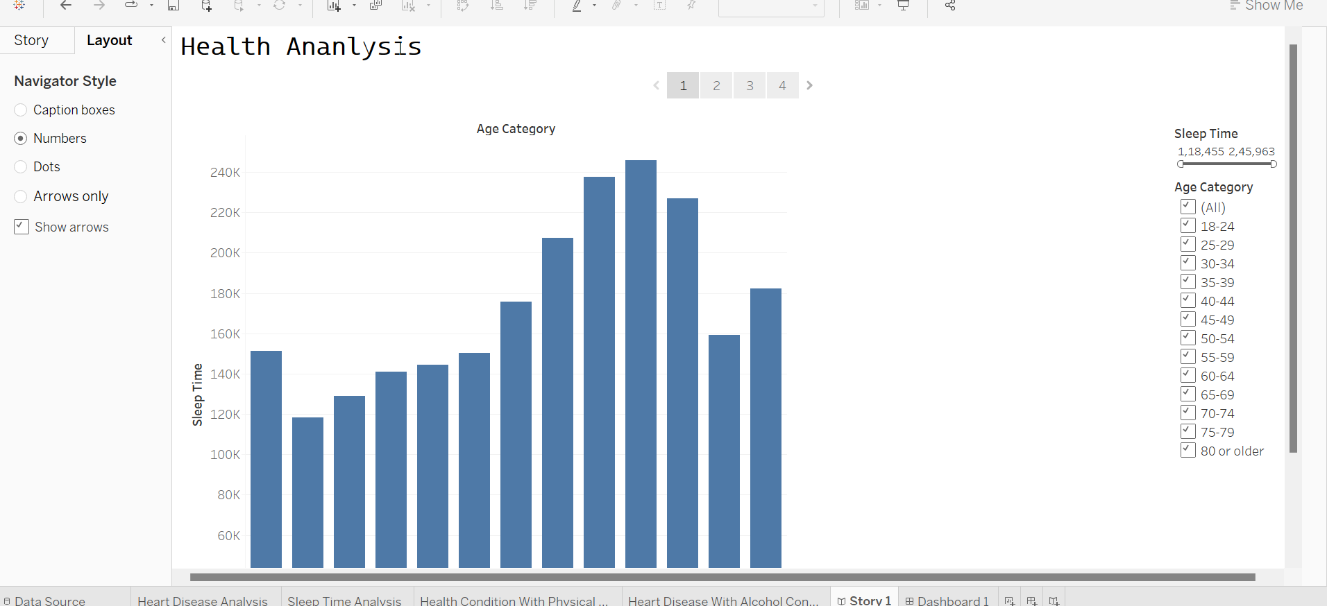 2. 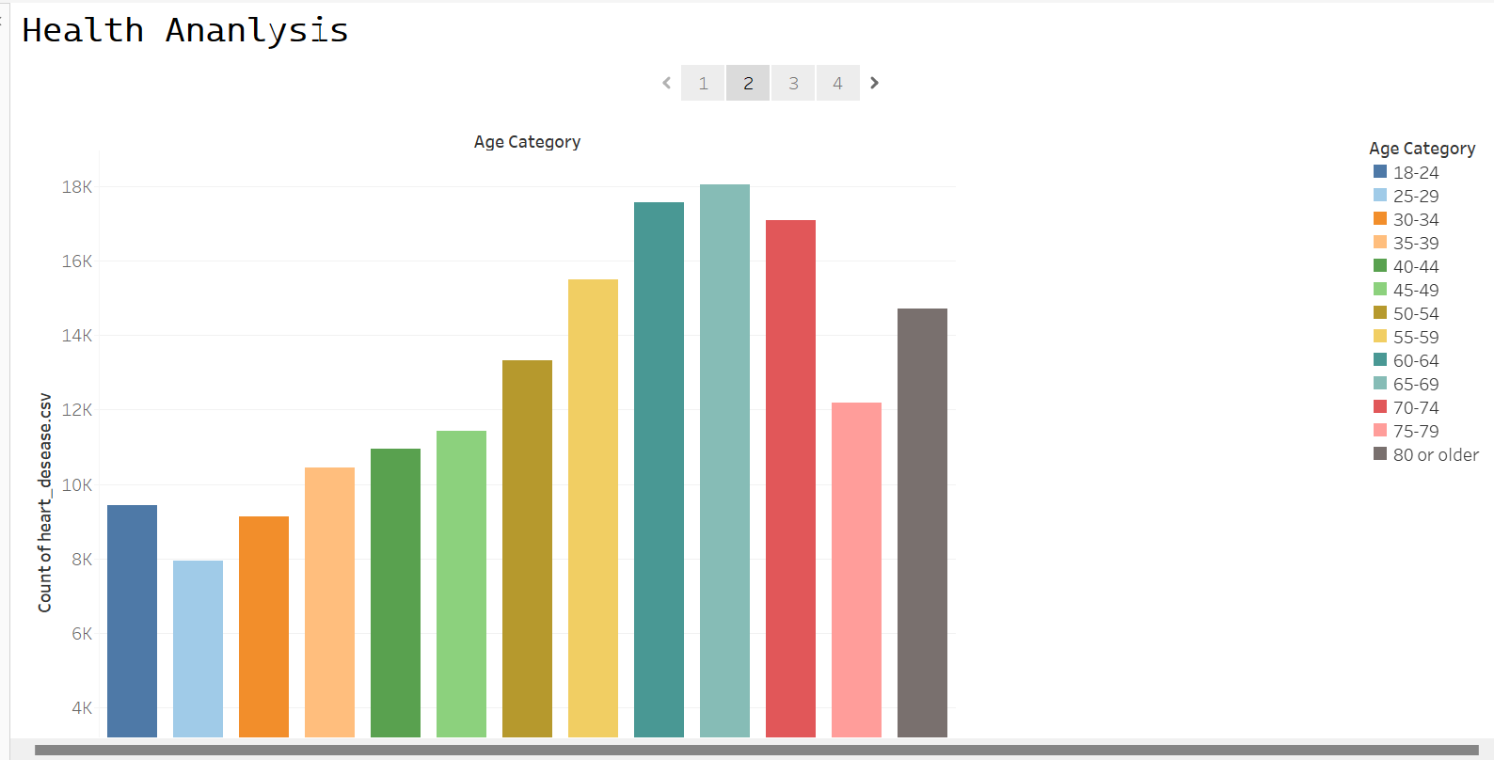

3. 